FOUNDATION UNIVERSITY ISLAMABAD
SCHOOL OF SCIENCE AND TECHNOLOGY

ASSIGNMENT NO 1

NAME: ALISHBA HAFEEZ
SUBJECT: PF (programming fundamentals) LAB
SECTION: 25 “B”
DEPARTMENT: BS IET
DEADLINE: 08/10/2025
ROLL NO: 1025234338
INSTRUCTOR: Mr. GHAZIF ADEEM

LAB MANUAL
TASKS

TASK 2.1:
Write a C++ program, which declares integer ‘a’, float ‘b’, and character ‘c’. Ask the user for integer value and store it in ‘a’, for a float value and store it in ‘b’, and for a character value and store it in ‘c’. At the end, print the values of those three variables on the screen. Your output should be as below. Indent your code and include comments for improving the readability of your code.

SOLUTION:
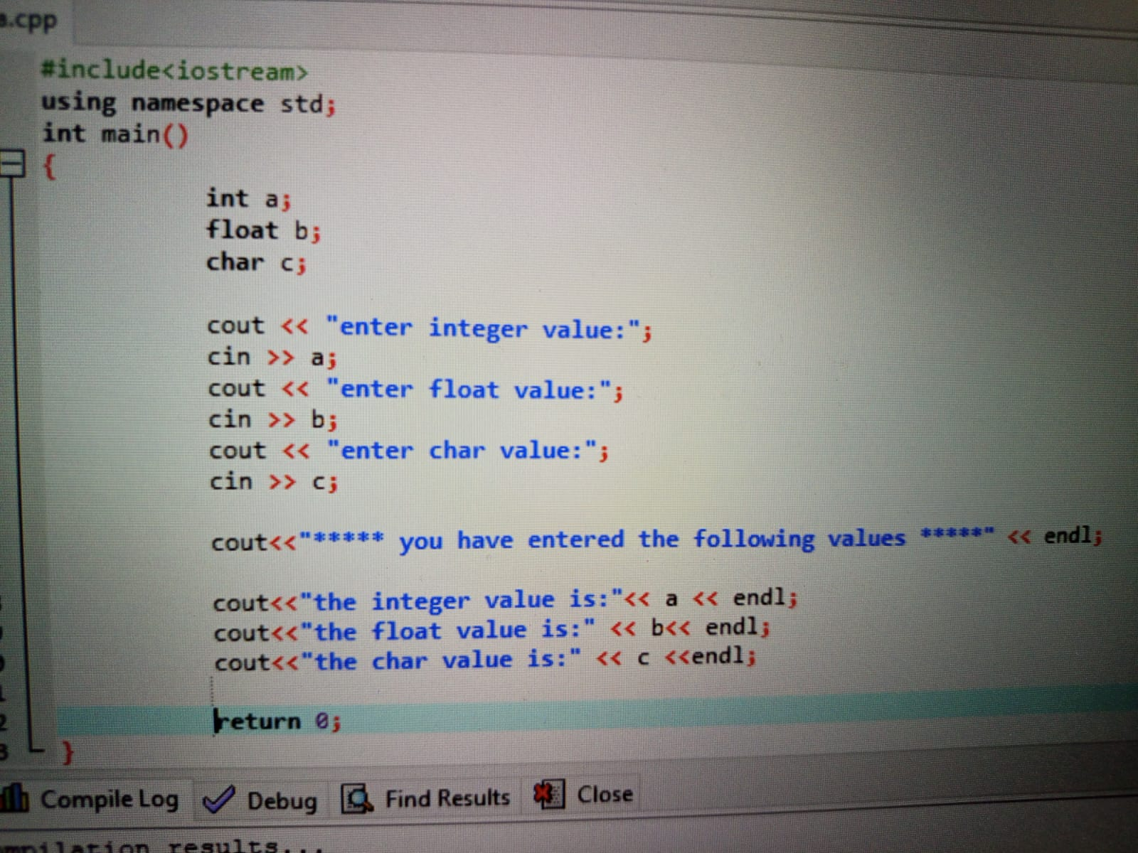

OUTPUT:
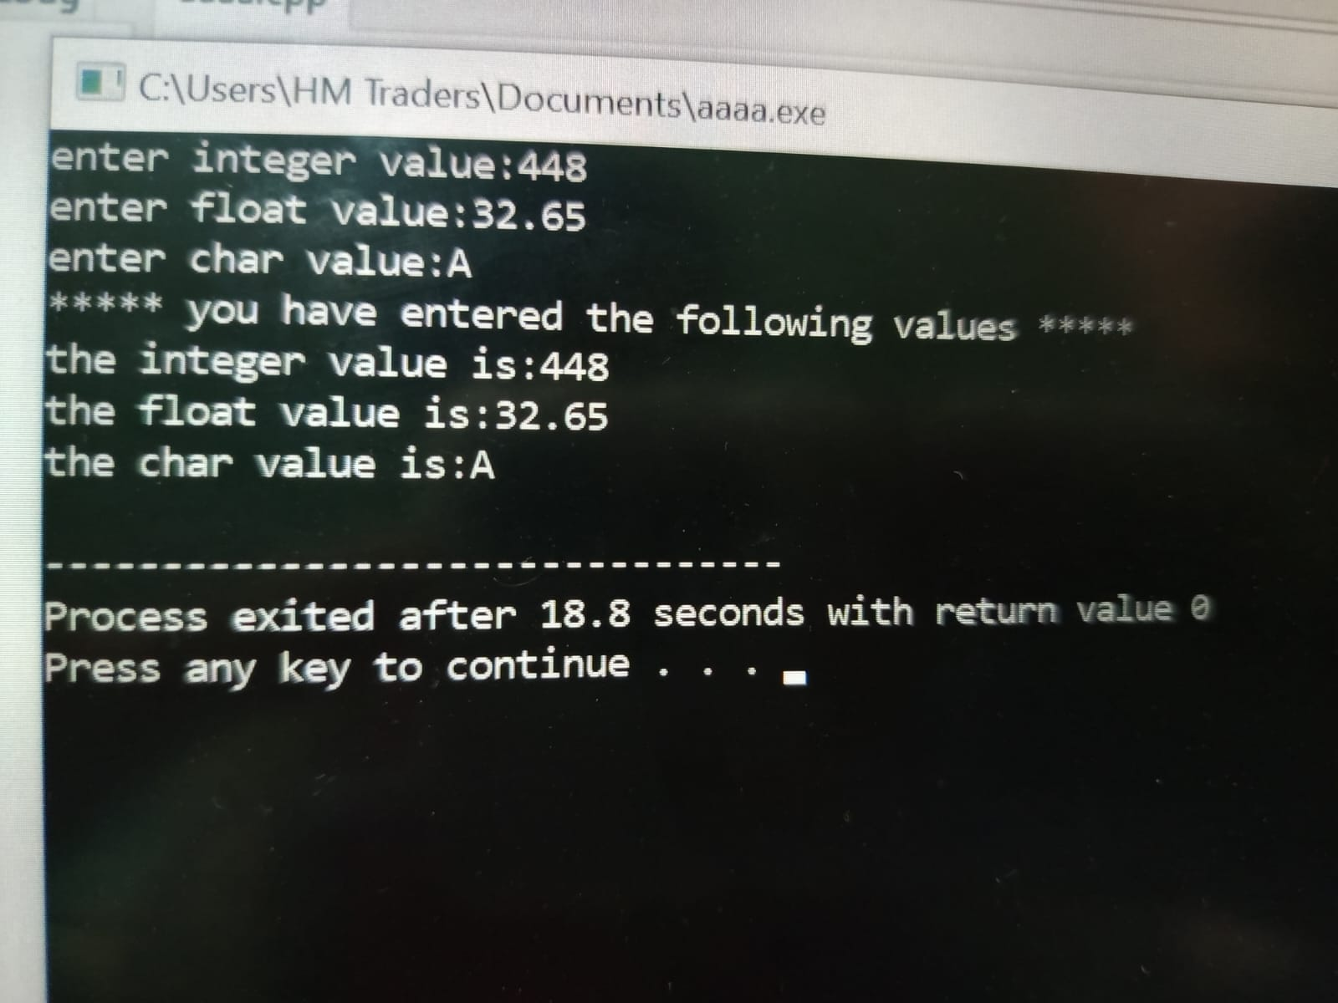

TASK 2.2:
Write a C++ program that takes two integer values from user and computes their sum, difference, product, quotient, remainder. At the end, print these results on the screen with a beep. Your output should be as below. Indent your code and include comments for improving the readability of your code.
SOLUTION:

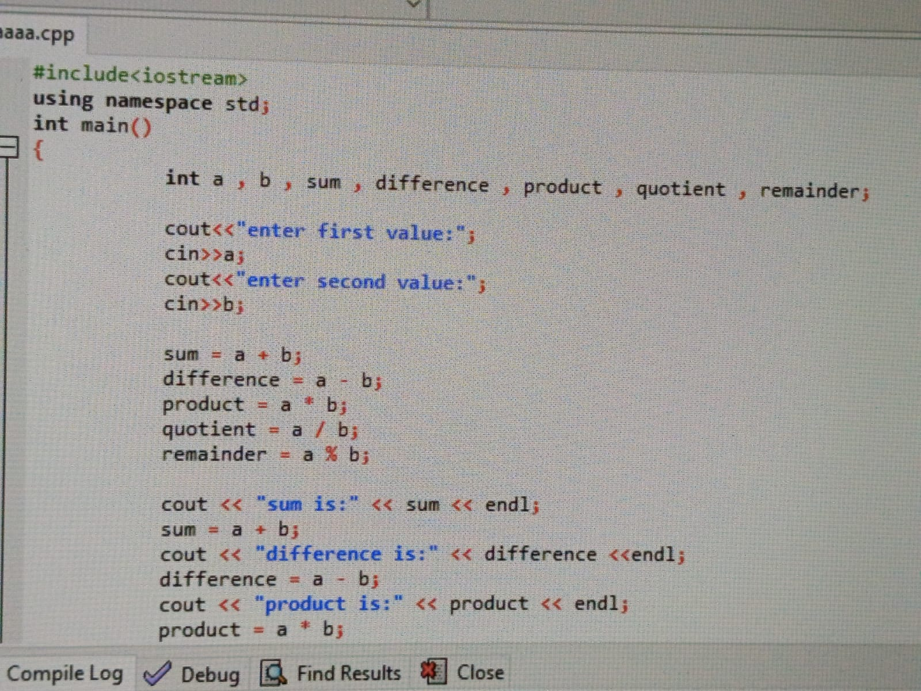
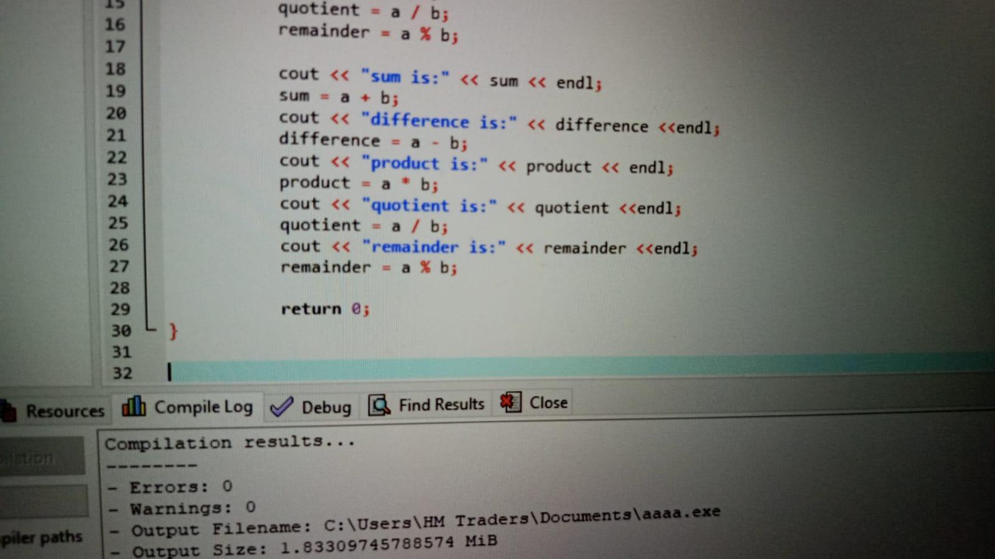
OUTPUT:
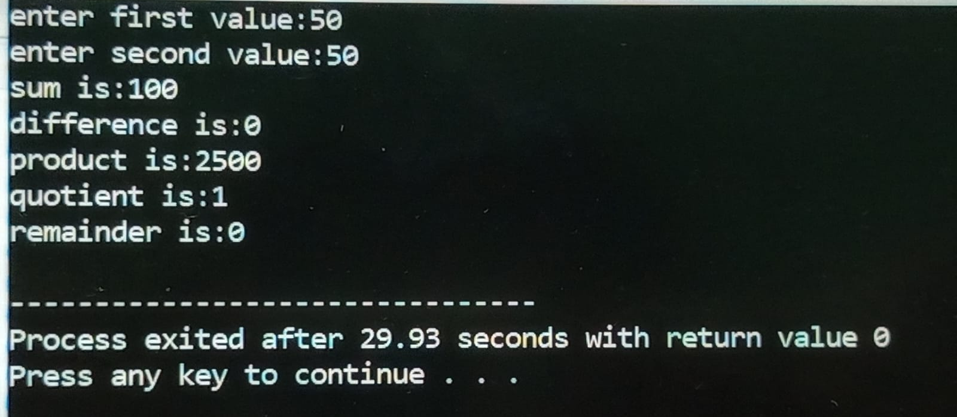

TASK 2.3:
Write a C++ program that takes a temperature value in Celsius as input and converts it to Fahrenheit.
HINT: (C * 9/5) + 32
SOLUTION:
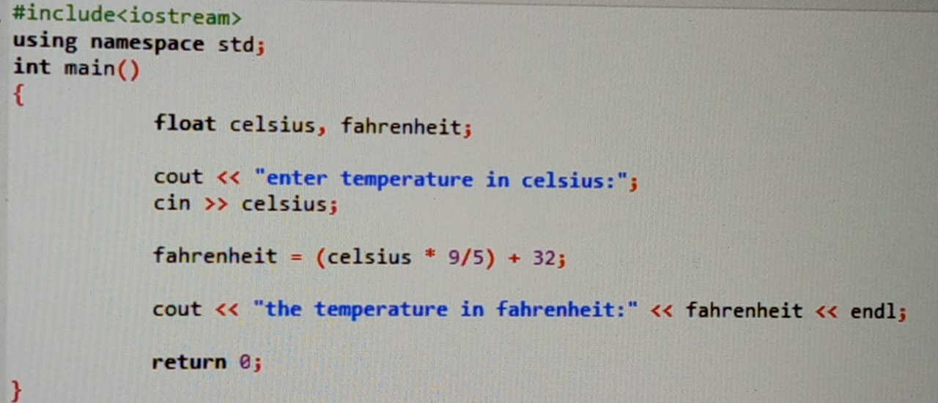
OUTPUT:
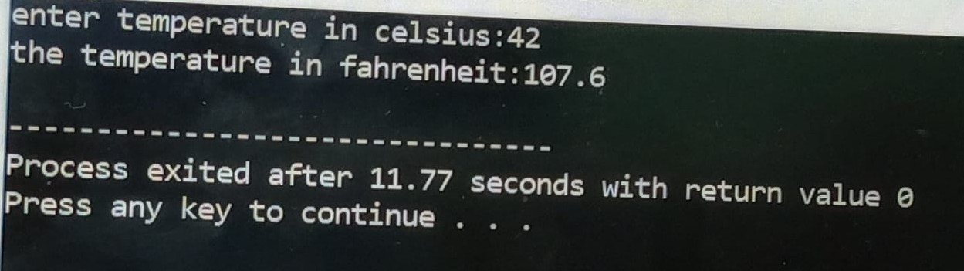

TASK 2.4:
Write a C++ program that takes two integer values from the user calculates their sum and then increments it using the pre-increment operator ++, and finally prints the result to the standard output.

SOLUTION:
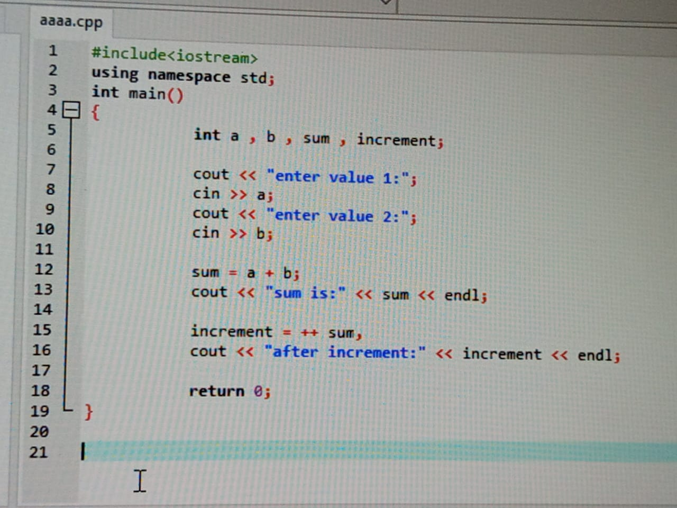
OUTPUT:
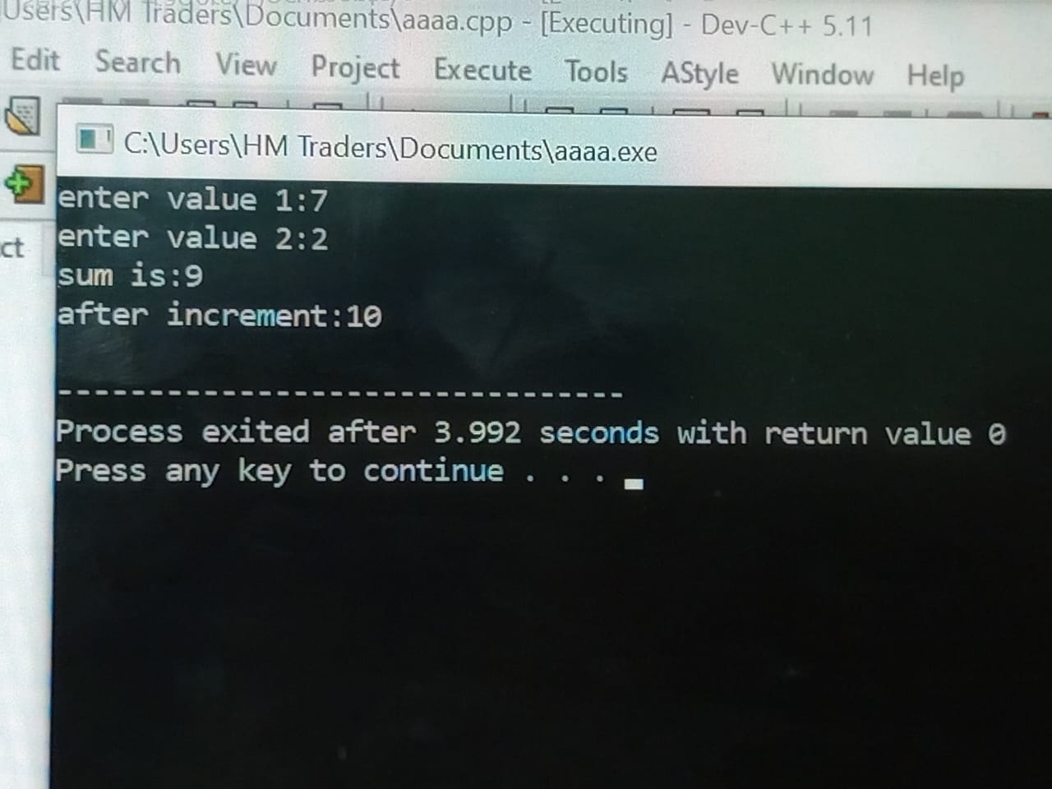

TASK 2.5:
Write a C++ program that takes two integer values from the user calculate their sum and then decrements it using the pre-decrement operator --, and finally, prints the result to the standard output.

SOLUTION:

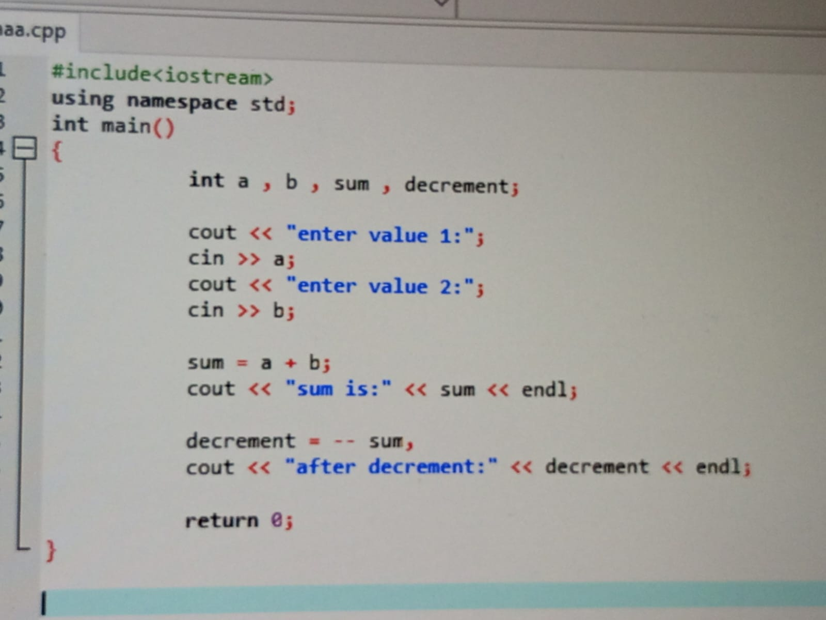
OUTPUT:
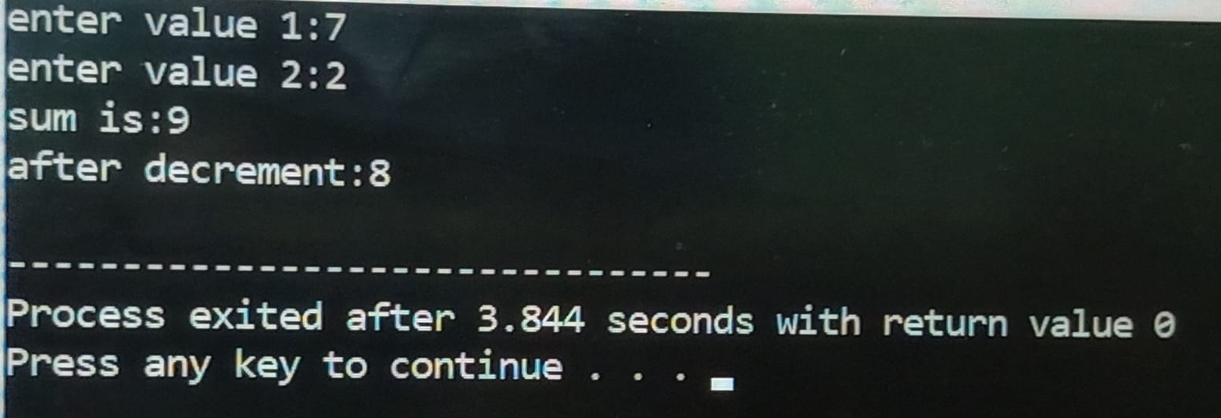

TASK 2.6:
Write a C++ program that collect two integer values from the user, calculates their remainder using the modulo operator (%) and then increment the remainder using the pre-increment operator ++, display the final remainder on the console.

SOLUTION:
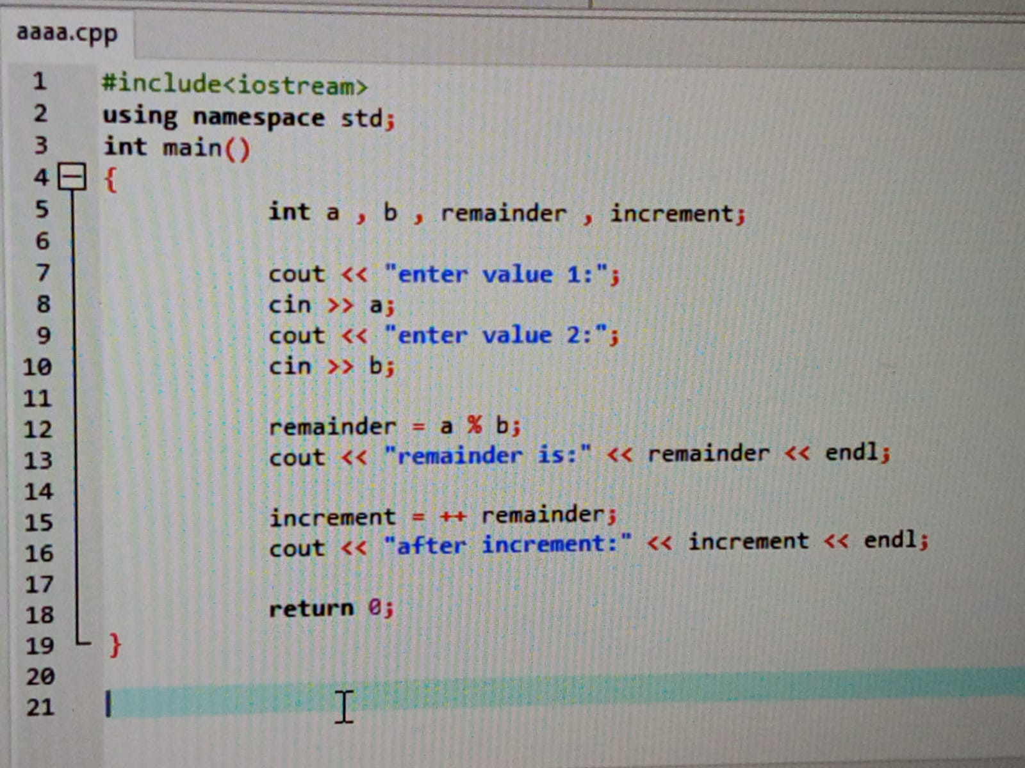
OUTPUT:
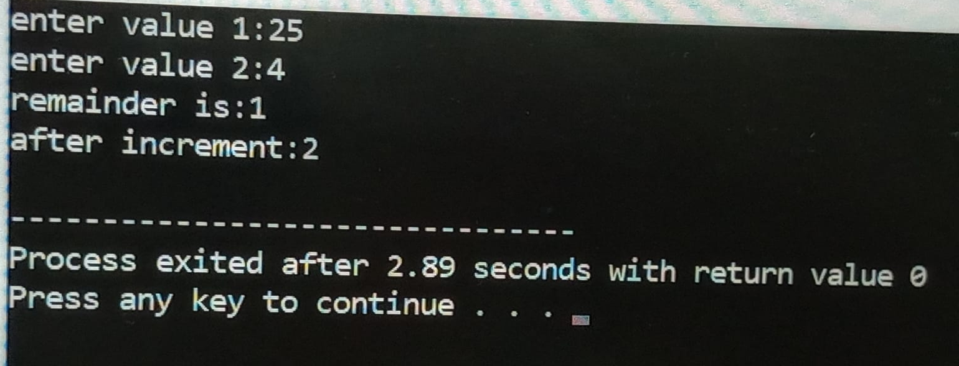

TASK 2.7:
By using different escape sequence, write a C++ program, which displays the following output. After every line, your program must generate a beep. If you already do not know the escape sequence for generating a beep, find it out for yourself indent your code and include comments for improving the readability of your code.

SOLUTION:

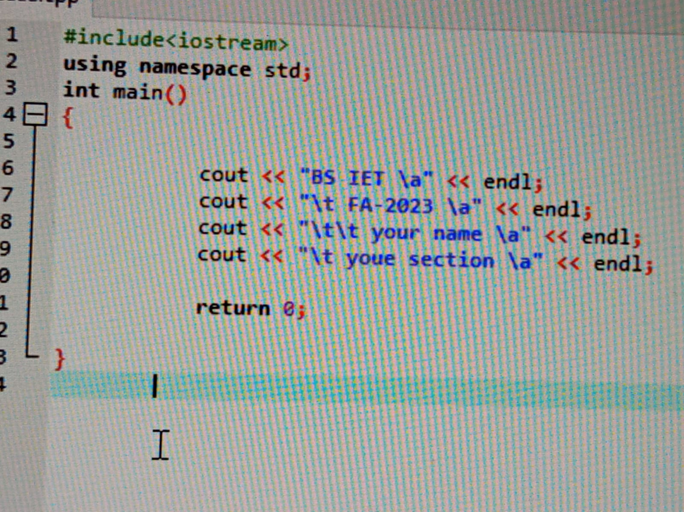
OUTPUT:
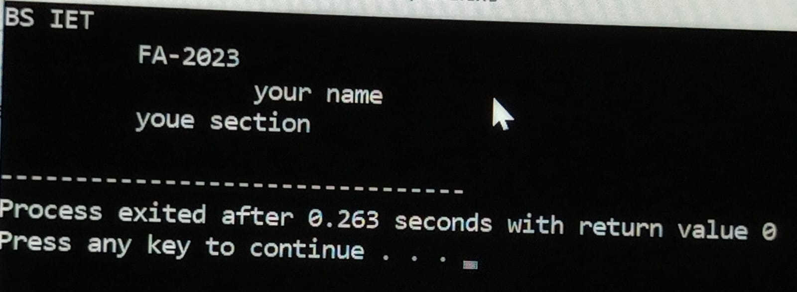

EXERCISE QUESTIONS
2.1 (arithmetic):
Write a program that inputs three integers from the keyboard and prints the sum, product, average the screen dialog should appears as follows.

SOLUTION:
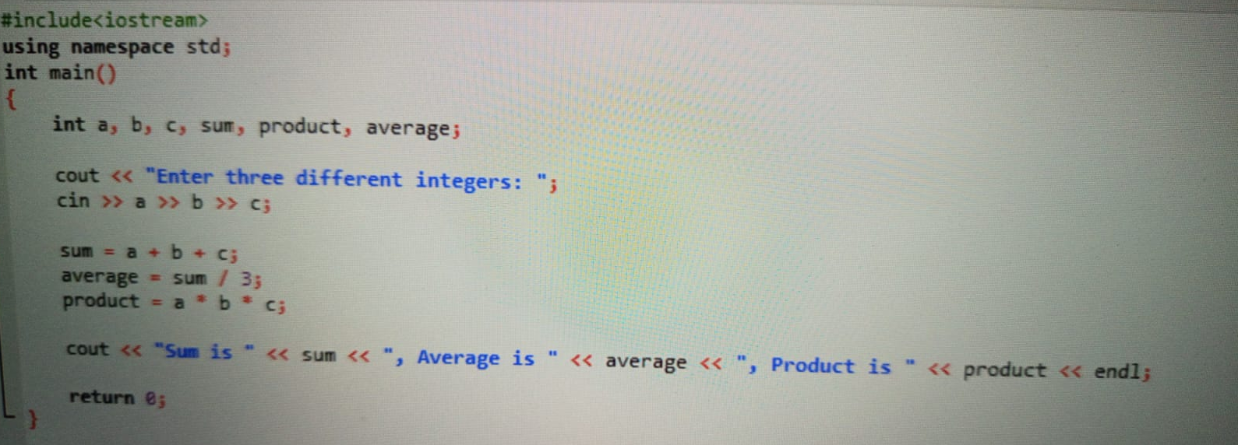
OUTPUT:
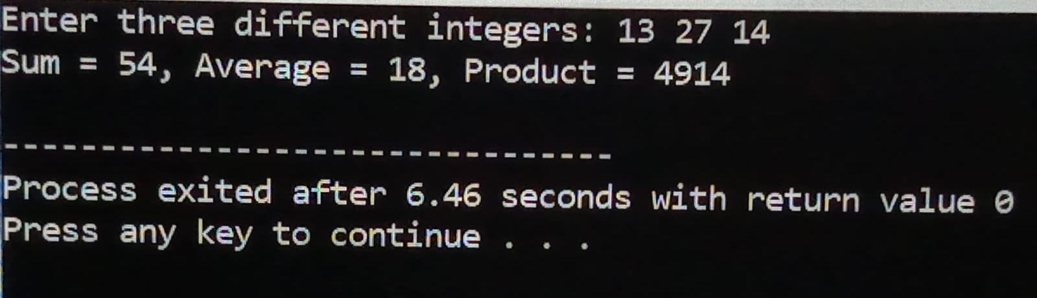

2.2 (displaying shapes with asterisks):
Write a program that prints a box and an oval, as follows.

SOLUTION:
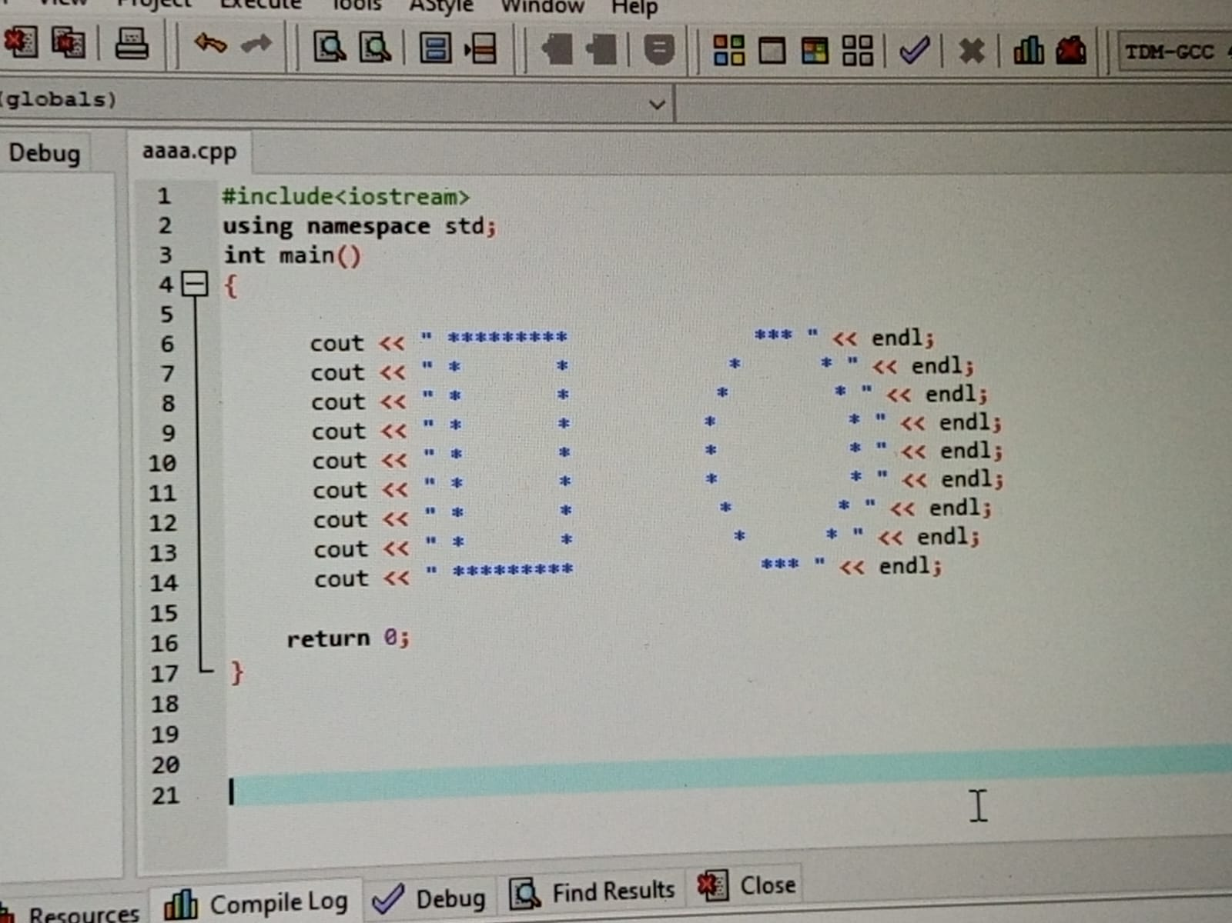
OUTPUT:
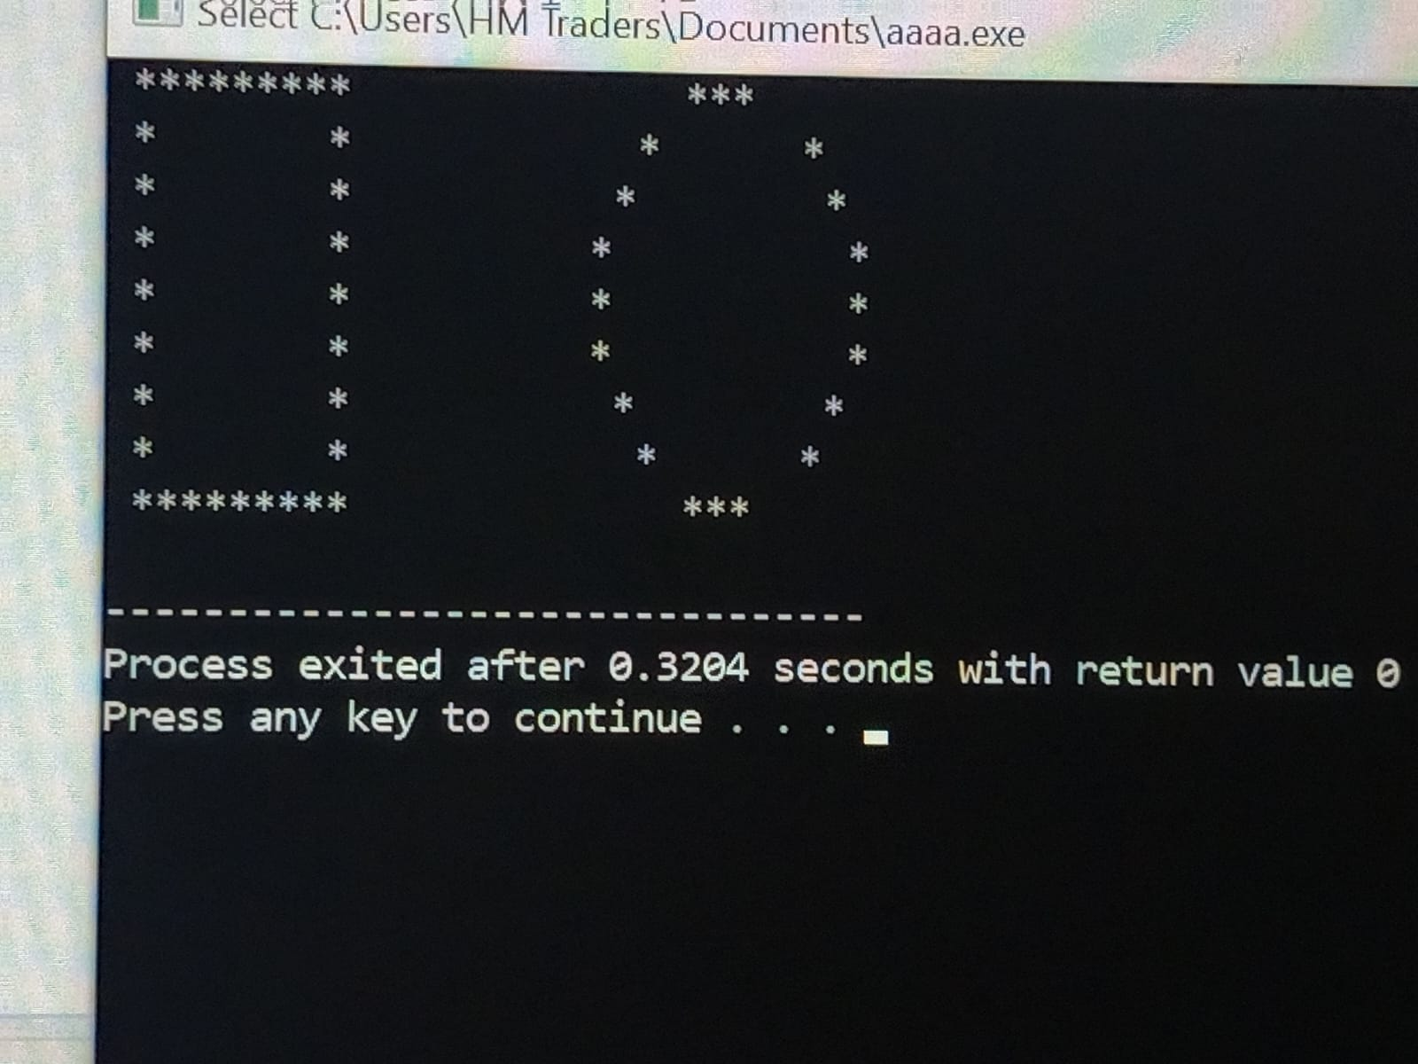

2.3 (table):
Using the techniques of this chapter write a program that calculates the square and cube of the integers from 0 to 10. Use tabs to print the following neatly formatted table of values.

HINT: square of x = x * x
Cube of x = x * x * x
SOLUTION:
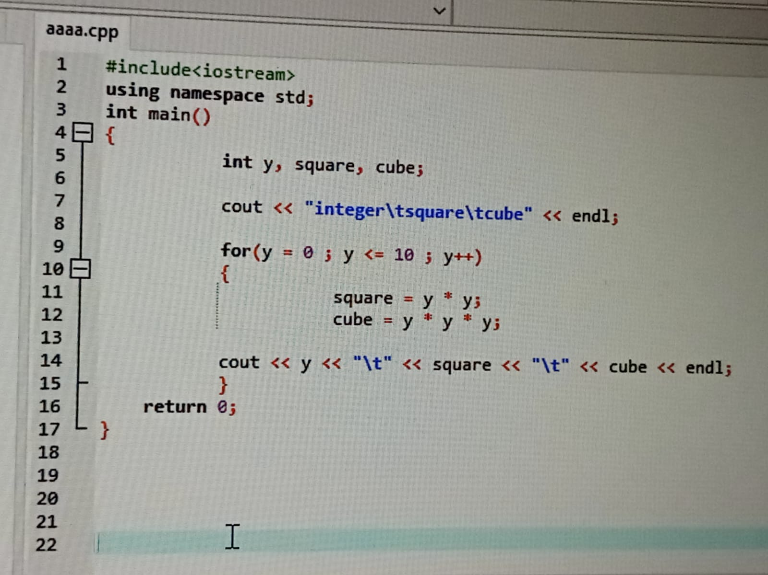
OUTPUT:
